STA 360 13.8kV HYDE PARK BESS

- GENERAL DESCRIPTION

The primary objective of the proposed project is to help relieve the heavy loading condition of Hyde Park Substation #496. This project includes the design and implementation of Protection and Control (P&C) systems for the new STA-360 Hyde Park BESS Substation and associated relay upgrades at existing STA-496.

The project consists of the installation of a 10 MW / 20 MWh utility-scale battery energy storage system to mitigate loading constraints at Hyde Park Substation #496 and provide a mid-term capacity solution prior to implementation of the long-term area supply plan.

At STA-360, the project includes the installation of a Battery Energy Storage System (BESS) to support grid reliability and operational flexibility. The scope involves integrating the battery storage system with the existing substation infrastructure, including protection and control, metering, communication, and control interfaces. The battery storage will provide system support functions such as load management, reliability improvement, and operational support as required.

The Hyde Park BESS will be located on Eversource-owned property at 427 Cummins Highway, Boston, MA, adjacent to Hyde Park Substation #496. The BESS will operate in parallel with the Eversource distribution system and will be interconnected at 13.8 kV.
The BESS will:
- Reduce substation peak loading via peak shaving
- Improve system reliability during peak demand periods
- Provide operational flexibility during contingencies
- Serve as a temporary solution until long-term transmission upgrades are in service

- Detailed Description

- STA 360

The new station 360 will consist of four (4) feeder breakers and four (4) distribution lines. Each line will be protected by two independent protection systems. System 1 protection will utilize an SEL-351S relay, and System 2 protection will utilize an SEL-751 relay. Each line will have its own dedicated protection and control cabinet, resulting in a total of four (4) individual line relay cabinets.

The deliverables are as follows:
- Prepare and update one-line and three-line diagrams for metering, relaying, station configuration, and construction interfaces.
- Develop DC elementary, control, logic, communication, HMI, alarm, timing, and network drawings for the scoped systems.
- Prepare panel design documentation, including panel layouts, wiring diagrams, termination details, and bills of material (BOMs), as required.
- Incorporate and reference applicable OEM/vendor panel and equipment documentation within the design package.
- Develop control house layout drawings, including equipment footprints, clearances, cable routing, and installation requirements for scoped equipment.
- Design the Station 360 SCADA/RTU system, including network architecture, time synchronization, Orion+ RTU implementation, HMI screens, data concentrators, and a complete SCADA points list.

Station 360 relays are as follows:
- 13.8 kV Feeders/GSU Interconnections: Four feeders, each with one SEL-351S System 1 relay and one SEL-751 System 2 relay.
- Install an SEL-735 (Power Quality Meter) and Revenue Meter on each line for real-time monitoring of voltage, current, power, energy, frequency, and other electrical parameters.

Protection schemes to be included:
- A Transfer Trip/Disconnect Scheme will be implemented for trip signaling between Station 496 and Station 360. Design will be coordinated between both stations.

- 13.8kV Line System 1 (S1)

S1 protection will be provided by a new Schweitzer SEL-351S microprocessor-based multifunction relay. The Protection 11S1 will function as the primary control relay for feeders’ protection.

This will provide time-delayed tripping protection for phase- fault and ground-fault protection on 13.8kV feeders.

Device  Designation | Relay Element  ANSI/IEEE | Description
SEL351S1 | 51 | AC Time Delay Overcurrent
SEL351S1 | 50 | AC Instantaneous Overcurrent
SEL351S1 | 50BF | Breaker Failure Scheme
SEL351S1 | 27 | Undervoltage
SEL351S1 | 81 | Frequency Relay
SEL351S1 | 79 | Ac Reclosing Relay / Auto Reclose
SEL351S1 | 25 | Synchronizing or Synchronism-Check Device

- 13.8kV Line System 2 (S2)

S2 protection will be provided by a new Schweitzer SEL-751 microprocessor-based multifunction relay. Protection 11S2 will function as the primary control relay for feeders’ protection.

This will provide time-delayed tripping protection for phase- fault and ground-fault protection on 13.8kV feeders.

Device  Designation | Relay Element  ANSI/IEEE | Description
SEL751S2 | 51 | AC Time Delay Overcurrent

- STA 496

The following 13.8 kV feeders originating from STA-496 will be re-terminated / extended to STA-360 as part of this project:
- 496-H7
- 441-1401H
- 362-1207H
- 362-1209H

Design to replace the existing feeder and transformer secondary feeder breaker relays at Station 496 Hyde Park. The scope includes the upgrade of feeders 496-H7, 441-1401H, 362-1207H, and 362-1209H, including the design of protection, metering, and transfer trip interfaces between Station 496 Hyde Park and Station 360.

The deliverables are as follows:
Engineering deliverables will include all required protection, control, communication, logic, wiring, and associated design documentation necessary to support relay replacement, installation, testing, and commissioning. Develop SCADA point lists for the RTU (Orion+ or similar) and for the SEL RTAC/AXION devices being used for alarming and as data concentrators. Design transfer trip signaling between Station 496 Hyde Park and the associated feeders at Station 360 using dedicated dark fiber. All designs shall be developed in accordance with the latest Eversource standards, applicable industry standards, utility best practices, and NERC reliability requirements.

Station 496 relays are as follows:
- Replace each feeder’s existing System 1 relay (SEL-551) and associated equipment, with one new SEL-351S and associated equipment. Four in total. It will be determined during design if a SEL-451 is required instead of a SEL-351S to achieve sync check.
- Replace each feeder’s existing System 2 relay (ABB REF610) and associated equipment, with one new SEL-751 and associated equipment. Four in total.
- For each 13.8 kV transformer associated with the feeders listed above, replace the existing System 1 relay (SEL-551) and associated equipment with one new SEL-351S and associated equipment. Four in total.
- For each 13.8 kV transformer associated with the feeders listed above, replace the existing System 2 relay (ABB REF610) and associated equipment with one new SEL-751 and associated equipment. Four in total.
- For each 13.8 kV transformer associated with the feeders listed above, install one new SEL-735 and associated equipment for metering. Four in total.

- RTU

Station 360 will include one (1) RTU cabinet to provide SCADA monitoring, control, status indication, plant controller and communication interfaces for the entire station.
Perform SCADA/RTU engineering and design for Station 360, including development of the communications architecture, time synchronization system, and RTU ORIONLX integration required to support station monitoring and control. The scope includes the design of engineering access and SCADA communications infrastructure, network connectivity and port mapping, integration of Owner-selected networking and security equipment, and development of all associated panel layouts, interconnection and termination drawings, cable schedules, control power distribution, grounding, labeling, and point mapping documentation. The design shall incorporate the SEL-2488 GPS Clock for time synchronization and the ORIONLX RTU for data acquisition and communications, including all required power, grounding, communication interfaces, and SCADA point integration. All design documentation shall support system integration, testing, commissioning, and operation in accordance with Eversource standards and project requirements.
Perform Human Machine Interface (HMI), alarm system, and data concentrator engineering and design for Station 360. The scope includes development of HMI requirements utilizing the SEL RTAC SEL-3355 with HMI package and touchscreen display, including installation requirements, network connectivity, and status/alarm indications associated with the SCADA points list. In addition, provide design documentation for SEL RTAC SEL-3555 data concentrator/plant controllers to be installed, including communications architecture, device connectivity, and integration of standard protocols such as IEC 61850 MMS, IEC 61850 GOOSE, Modbus TCP, and DNP3.0 to support station monitoring, control, and data acquisition functions.

- Plant Controller Modes of Operation

The Hyde Park BESS Project is intended primarily for grid-connected operation reducing peak load demand of the distribution systems. At the minimum, the BESS, and the Power Plant Controller (PPC) shall support the operating modes listed in the Table below. Scope will provide list of all available standard and optional operating modes and indicate which operating modes will be remotely controlled versus locally (or autonomously) controlled by the BESS unit. All functions will be "autonomous" and both Locally and Remotely controlled.
PPC operating modes
No. | Operation Mode | Description
1 | Stop | Shutdown, Offline, Disconnected from Grid, Auxiliary power disconnected. BESS facilities main breaker is open waiting for the Remote Terminal Unit (RTU) command to close.
2 | Standby / Idle | BESS main breakers are closed but inverters are disconnected. BESS unit is offline.
3 | Ready | Synchronized to the grid and connected, but no power is flowing.
4 | P & Q Command | While synchronized and connected to the grid, inject/absorb real and reactive power according to commands from the control system. The BESS should prioritize real or reactive power response.
5 | Automatic Voltage Regulation (AVR) | While synchronized to the grid, delivery of reactive power based on a voltage measurement at a pre-determined point on a grid for regulating the voltage at that point.
6 | Peak shaving | While synchronized to the grid, perform peak shaving functions, and reduce the import power from the grid at an adjustable level within the BESS capability. The power level should be adjustable remotely.
7 | Fast Frequency Response (FFR) – OPTIONAL | While synchronized to the grid, provide active power based on a frequency measurement at a pre-determined point on a grid for adjusting frequency at that point.
8 | Power Factor Regulation | While synchronized to a grid, delivery of reactive power based on a power-factor measurement for controlling the power factor at that point.
9 | State of Charge (SOC) Management | Delivery or absorption of real power to maintain required SOC within a preset range or limit based on real-time monitoring of power flow along the 500kV corridor.

- Control System Architecture

- Network Architecture
A three-tier control architecture as shown in Below Figure is proposed for the BESS plant. Each control tier is described in the following paragraphs:

- Tier 1 - Unit controls: responsible for controlling each power block, BMS controls, PCS controls, and all control, protection and safety devices associated with power blocks.
    - One unit controller per power block (4 in total) is recommended.
    - Preference is to utilize SEL RTAC type device (open-access automation controller) for each unit controller.

- Tier 2 – Plant controls: a Real-Time Automation Controller (RTAC) acting as the Plant Controller for implementing the BESS applications, coordinating the operation of 4 power blocks, and automating the plant / sub-plant interconnection to various feeders in normal and contingency conditions (such as loss of a bus/feeder or transformer). It is recommended that the plant controller be an SEL RTAC device. However, if alternative real-time platforms are used as the plant controller. Additional functionalities for the Power Plant Controller are:
    - System automation
    - 13.8 kV protection management
    - BESS applications and use cases: peak shaving, feeder thermal limit management, voltage control, control mode management, frequency response (optional), etc.
    - Plant-level SCADA and data/event logging.
    - Plant-level physical and cyber security management.
    - Plant-level fire alarm and explosion prevention.
    - Integration with Eversource grid interfacing equipment (P&C, Enterprise SCADA, etc.)

- Tier 3 – Enterprise (SCADA) controls: providing remote operator monitoring and control at control center through full integration with Tier-2 control level.

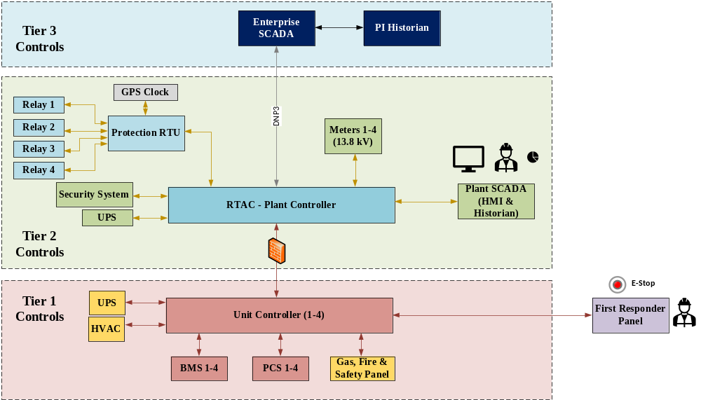
Control System Proposed Architecture

- Real-time alarm and status monitoring
The BESS site controller/controllers will optimize the utilization of battery. It shall have Metering and SCADA equipment for real-time monitoring of analog and discrete data points on a Human Machine Interface (HMI), and for obtaining historical data trending of metered values, and alarm/event logging. Controls and visibility shall be available at the BESS Control Rooms, and SCADA.
- As a minimum, Below Table provides a list of key data points (monitoring, status, and control parameters) that should be supported by the BESS site controller.

Monitoring Parameters | Control Parameters
Communication health status | Voltage setpoint at POI
Voltage measurement at BESS facilities POI | POI actual power flow and its limit
Current measurement at BESS facilities POI | Power factor setpoint at BESS POI
Voltage phasor measurement | Permission to charge/discharge for BESS
Current phasor measurement | BESS Active power dispatch setpoint
Active power at BESS POI | BESS Reactive power dispatch setpoint
Reactive power at BESS POI | BESS Emergency disconnect command (shutdown)
Energy measurement at BESS POI | Volt-VAR setpoints
Power factor measurement at BESS POI | Frequency-Watt setpoints
State of Charge for BESS | Startup/Shut down commands
Rate of charge for BESS | Peak shaving setpoint and status
Rate of discharge for BESS
Status of BESS POI breaker/ disconnect switches.
Frequency at POI
Control mode for BESS facilities
Thermal management parameters
Ambient Temperature
Active alarms and annunciations
Table 2-9. Minimum Key data points for information exchange of CCS with Coordinator’s SCADA

- OTHER WORK

    - Communications:

      - Communication:

New communication will be designed per sub-26. See drawings 360-XXXX.

    - AC/DC Power:

      - AC Power:
At Station 360, complete AC power will be provided from the new Station Service Transformer. Refer to the Substation Scope of Work for additional details regarding the station service design and associated equipment.

AC power feeds will be provided to all yard-mounted equipment, relay cabinets, and relays.

      - DC Power:

Provide dedicated DC battery systems for each individual cabinet.
For more information see Substation scope.

DC feeds will need to be run to the primary/secondary relaying.

    - Control/Relaying Cabinets:

Four (4) new 24” x 32” individual stand along cabinets will be added at STA360

- SUMMARY OF MAJOR EQUIPMENT TO BE INSTALLED
Note that the 360-8201 series of drawings provide a complete material list for that cabinet’s application.

    - P&C:

        - STA360 13.8kV Line Relay Cabinet

There are Four (4) S1 13.8kV line relay cabinets, one each for lines 496-H7, 441-1401H, 362-1207H and 362-1209H. These cabinets are based on drawing 360-8201.

        - RTU Cabinet

There is only one (1) RTU cabinet at STA 360. This cabinet is based on drawing 360-8201.

C) STA 496 Custom Plates

There are Eight (8) individual Custom Relay Plates for Transformer 110A Secondary Relay cabinet, Transformer 110B Secondary Relay cabinet and for feeders 496-H7, 441-1401H, 362-1207H and 362-1209H Secondary Relay cabinets.

- APPENDIX A – PROPOSED ONE LINE:
See attached drawing 360-1103 SH1, 496-10
- APPENDIX B - STATION LAYOUT:
See substation scope for control building.

